Historical Guided Kayak Trip on the Milwaukee River with Sherri Mertz
Saturday, September12th 2 PM- 5 PM
$60 per person includes kayak, life vest and paddle

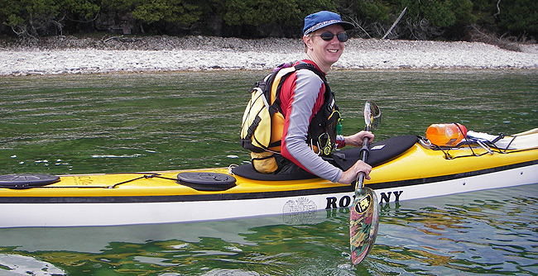

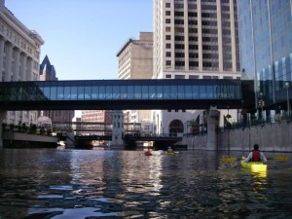

If you’re interested in the history of Milwaukee along its river, this trip will be 3 hours well spent! Enjoy the beautiful downtown waterfront from a new perspective in the seat of a canoe or kayak. Learn about the history of the river and the city that grew up on its banks. No experience is necessary, and all paddling equipment is provided.
Sherri has a degree in physical education and has worked as a teacher, environmental educator, camp counselor, program director, camp director, and kayak instructor/guide. In 2000, she took a job as the camping and paddle sports department manager at Laacke & Joys, an outdoor store located on the Milwaukee River in downtown Milwaukee, WI. She started the Adventure Education Program for the store and ran it for the next eight years before leaving to start Sherri Kayaks Outdoor Programs in spring 2009.
RSVP by August 12th to:
ART BARTLING: 262-784-3594
JAN VOGT: 414-218-6673

