Saturday, July 25th Kayak with the Schussboomers on the Mecan River Princeton, WI
Meet at 9:30 AM Launch by 10:00 AM approx. 2-3 hour paddle
Single Kayak including paddle and life vest $34 BYOB $15 roundtrip shuttle
Lunch in the cozy restaurant 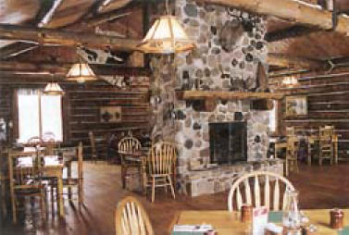
RSVP BY JULY 1st: ART BARTLING: 262-784-3594 JAN VOGT: 414-218-6673
Canoeing and Kayak Trips  There is nothing more pleasurable than floating a river. Canoe and kayak with us on one of central Wisconsin’s finest rivers. The Mecan, known for its great trout fishing, is a fantastic river to paddle. The current is lively and the clear sparkling water will entice you. The course of the Mecan is a bird watcher’s and photographer’s heaven. In the heart of the sand hill crane nesting area, you will be surrounded by many different species of birds, as well as deer, beaver, muskrats and other animals.  Paddle the Fox, a larger river rich in the history of the fur trading era. It was the major link for fur traders from the Great Lakes to the Mississippi. It is one of the few rivers in the nation that flows north. Efforts are underway to improve the river and preserve its history. | 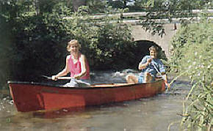
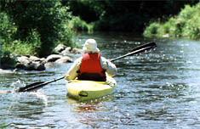 | Day tripping at its best  We provide canoe or kayak, paddles, personal flotation devices, and transportation both ways. We go over a river map with you, planning a trip that best suits you. You set the pace; the choice is yours. Minimum trip is two hours with options for all day or overnight. We will meet you for your shuttle back to our base. The peace and solitude along with our personalized service will bring you back for more.  We're open seven days a week during the summer season. We use top-quality equipment with our whole fleet being Old Town “Discovery” canoes and Wilderness System Kayaks.

